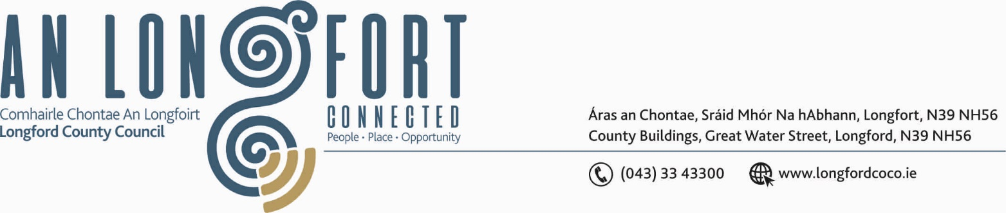

LONGFORD MUNICIPAL DISTRICT

21st June 2018.

To: Each Member of the Longford Municipal District.

A Chomhairleoir,

You are requested to attend the Annual Meeting of the Longford Municipal District to be held in the Council Chamber, Town Hall, Market Square, Longford on Wednesday, 27th June 2018 at 3.30 p.m. to transact business, as set out on the Agenda hereunder.


Mise le meas,

_______________
Anne Lee,
Meetings Administrator.

C L A R

1. Election of Cathaoirleach.

2. Election of Leas Cathaoirleach .

3. Fix date and time of Longford Municipal District meetings.

LONGFORD MUNICIPAL DISTRICT

21st June 2018.

To: Each Member of Longford Municipal District.

Dear Member,

You are requested to attend Meeting of Longford Municipal District to be held in the Council Chamber, Town Hall, Market Square, Longford, on Wednesday,
27th June 2018 at 4.00 p.m. to transact business, as set out on the Agenda hereunder.

Yours sincerely,

_______________
Anne Lee,
Meetings Administrator.

AGENDA

Prayer before meeting.

1. Confirmation of Minutes of the following meetings of Longford Municipal District–
(i) Committee Meeting held on the 2nd May 2018.
- Monthly Meeting held on the 2nd May 2018.

2. Matters arising from Minutes.

3. Management Report - enclosed.

4. Consideration of the Taking in Charge of “Rock View”, Clondra, Co. Longford -
details enclosed.

5. Consideration of recommendations from the Placenames Sub-Committee regarding the naming of the following -

- Business Park on the Athlone Road, Longford Town.
- Digi-hub in the Providers Building.

6. Consideration of recommendation from Corporate Policy Group -

“That a ban be put in place on all motorised vehicles on the walkways in the
Albert Reynolds Peace Park.”

7. Notices of Motions submitted by Councillors, as listed hereunder –

Councillor Joe Flaherty.

“I call on the Council to look at a Low Cost Safety proposal for the Lisbrack Rd, Longford, to include either ramps or flashing lights. The road is being used as a quick through road and cars are travelling at high speeds despite many young children living in the area.”

“With the works nearing completion on the paths in Teffia Park and works on the Annaly Park paths due later this year, can the Council look to ringfence funding to undertake works on the paths in Pearse Drive and Lisbrack. Very little works have been done on the Lisbrack Paths or the Estate since it was built nearly thirty years ago. In addition look at continuing the paths in line from the Demense houses to the Rugby Club along the Lisbrack Road. Pedestrians are not using the path which drops back and runs in line with the houses for approx 150 metres and it is a serious public safety issue with cars travelling at high speeds on this stretch of roadway.”

“To consider the provision of additional speed ramps at The Hollows and St Emer's Estates, in the interest and well being of the many young children living in both estates.”

Councillor Gerry Warnock.

“I am calling on Longford Municipal District to immediately reinstate the speed ramps which were removed from the road servicing Wards Tce/Congress Tce/St. Michael’s Road during the Cluid Regeneration of St. Michael’s Road a couple of years back. The road is used as a “rat run” between the N5 (Strokestown Road) and the N63 (Athlone Road). There is a high volume of daily traffic, including HGVs, and there are particular public safety concerns amongst the residents particularly that of child safety.”

Councillor Mae Sexton.

“That landscaping of the green area behind the wall opposite the newly levelled area on the County Council Great Water St site be undertaken immediately as part of the cleaning up of that whole area.”

“That the lights on the footpath outside of the apartment block at Eden Court on the Athlone Road be taken in charge.”

“That Longford Municipal District writes to owners of the Aldi Carpark site to ask that they clean up the area immediately and on a regular basis.”

8. Correspondence - circulated.

- Letter dated 20th April 2018 received from the Department of Agriculture, Food and Marine regarding the Control of Noxious Weeds on Public Lands.
- Letter dated 8th May 2018 received from Superintendent Jim Delaney.
- Letter dated 19th June 2018 received from Longford Pool Construction Co. regarding the proposal to have a container coffee shop located in the Mall Amenity area.
- Letter dated 8th May 2018 received from TII regarding Salt Barn at County Council Machinery Yard.

